Branching :

Like if want to run two activites at a time on same source why to create two sources for ame dataset just create one and make two copies of them as branches and use them

join

depatment

employee

aggeregate

employee

employee

Employee branch2

aggeregate

join

depatment

Employee branch1

1. Create source1 and source 2
2. Connect source 1 to aggregate unless you don’t connect to any activity you wil not get option for branch

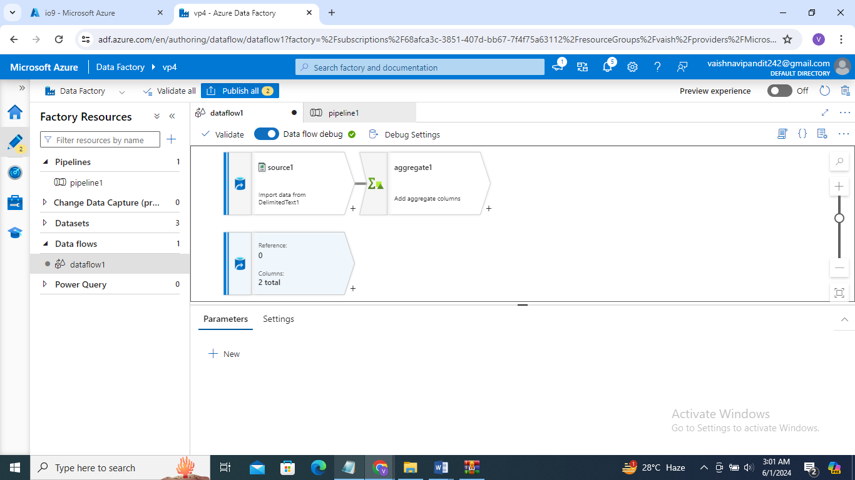

1. Now go t+ after source 1 and click on branch

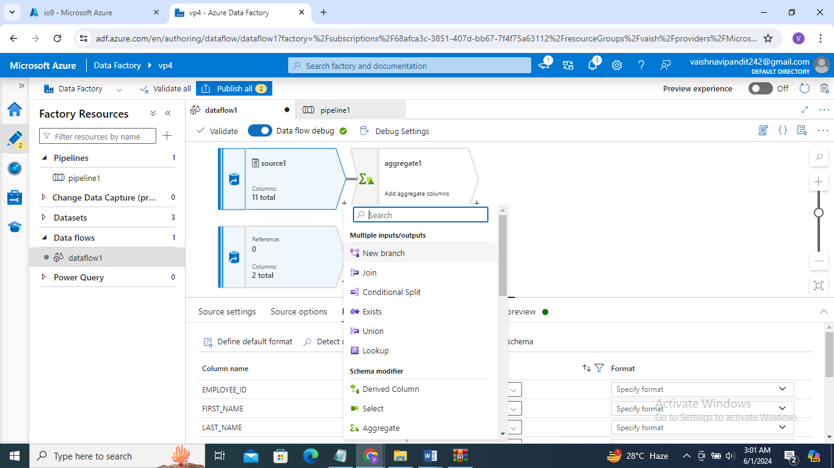

1. Now click + after branch and select join and add

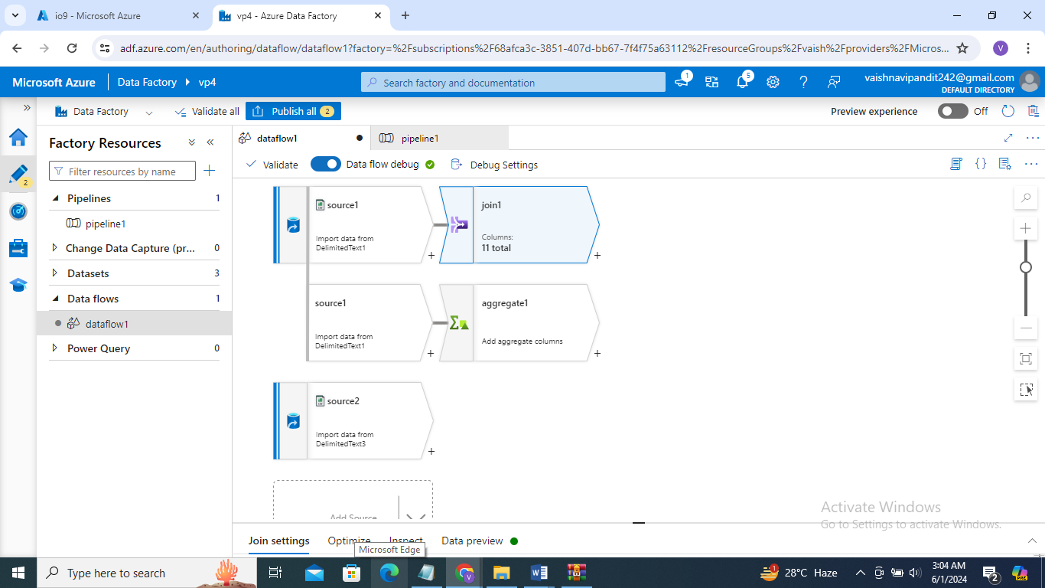

1. Now go to join and add right stream source2

